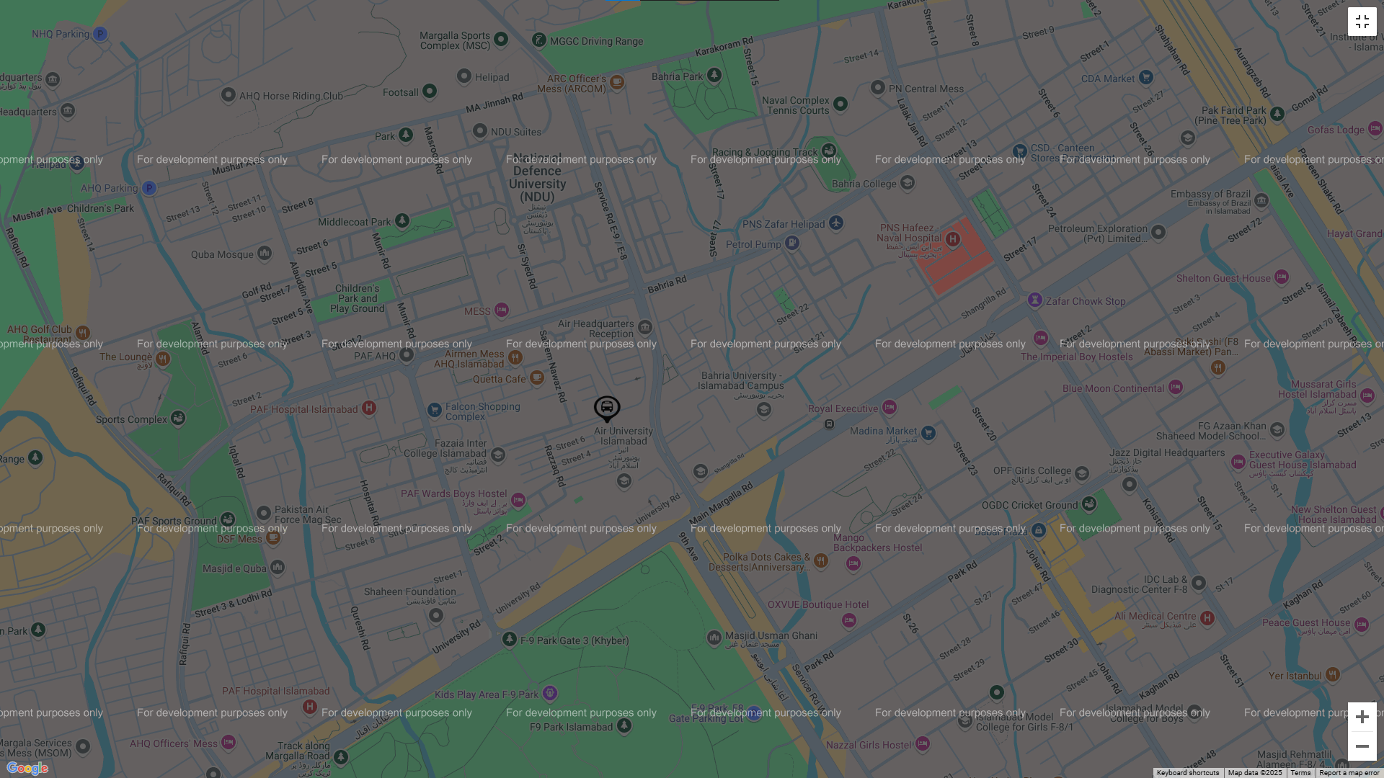
IOT Project
Bus Management and live tracking
Abdullah Tareen – 210690, Tehseen abbass – 211920, Ayesha yasir - 210695
Live Bus Tracking – IOT Project

Overview
This IoT-based bus tracking web and application is designed to enhance the convenience and efficiency of university transport for students. The system integrates GPS modules with MongoDB for real-time location tracking, an admin panel for centralized management, and a user-friendly interface for commuters.

Key Feature
The primary feature of this app is real-time bus tracking, allowing students to monitor bus movements and plan their commutes effectively. This reduces waiting times and enhances overall transport efficiency.

System Architecture
- IoT Integration: GPS module installed on buses sends real-time location data to a MongoDB.
- Database: MongoDB is used for storing bus locations, user data, routes, stops, and administrative records.
- Web Interface: Frontend is built using React.js for dynamic user experience. And Backend is on Node.js/Express.js is used to handle API requests and communicate with MongoDB.

Features
Admin Panel
Admins can add, edit, and remove:
  - Buses: Maintain buses records.
  - Drivers: Maintain driver records linked to buses.
  - Routes & Stops: Manage routes and stops assigned to buses.
  - Users: Control students access and details.
User End
- User Registration & Login: Secure authentication for personalized experiences.
- Profile Management: Users can add personal details and preferred stops for tracking.
- Live Location Tracking: Real-time display of bus location on Google Maps.
Integration with user-specific stop data for an enhanced tracking experience.

Website Interface – “Abdullah Tareen – 210690”
Landing Page.
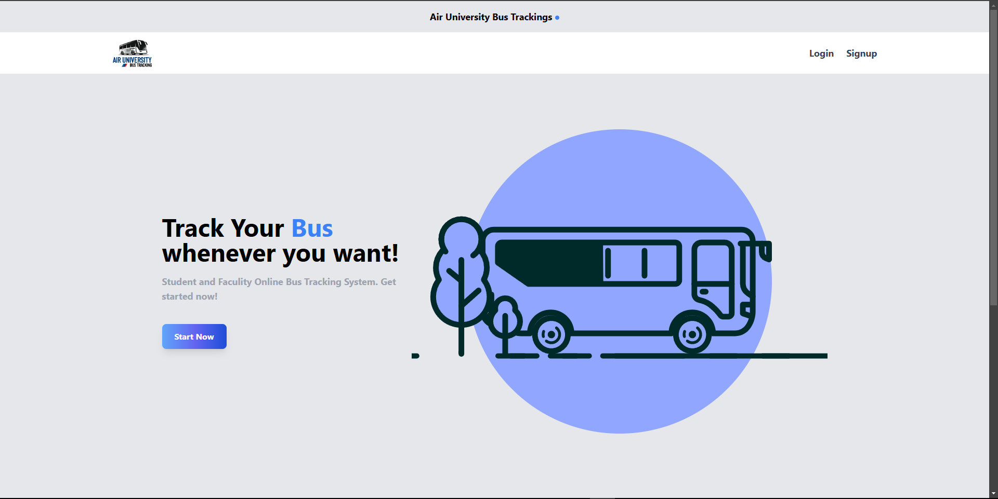

Signup Page / Registration Page
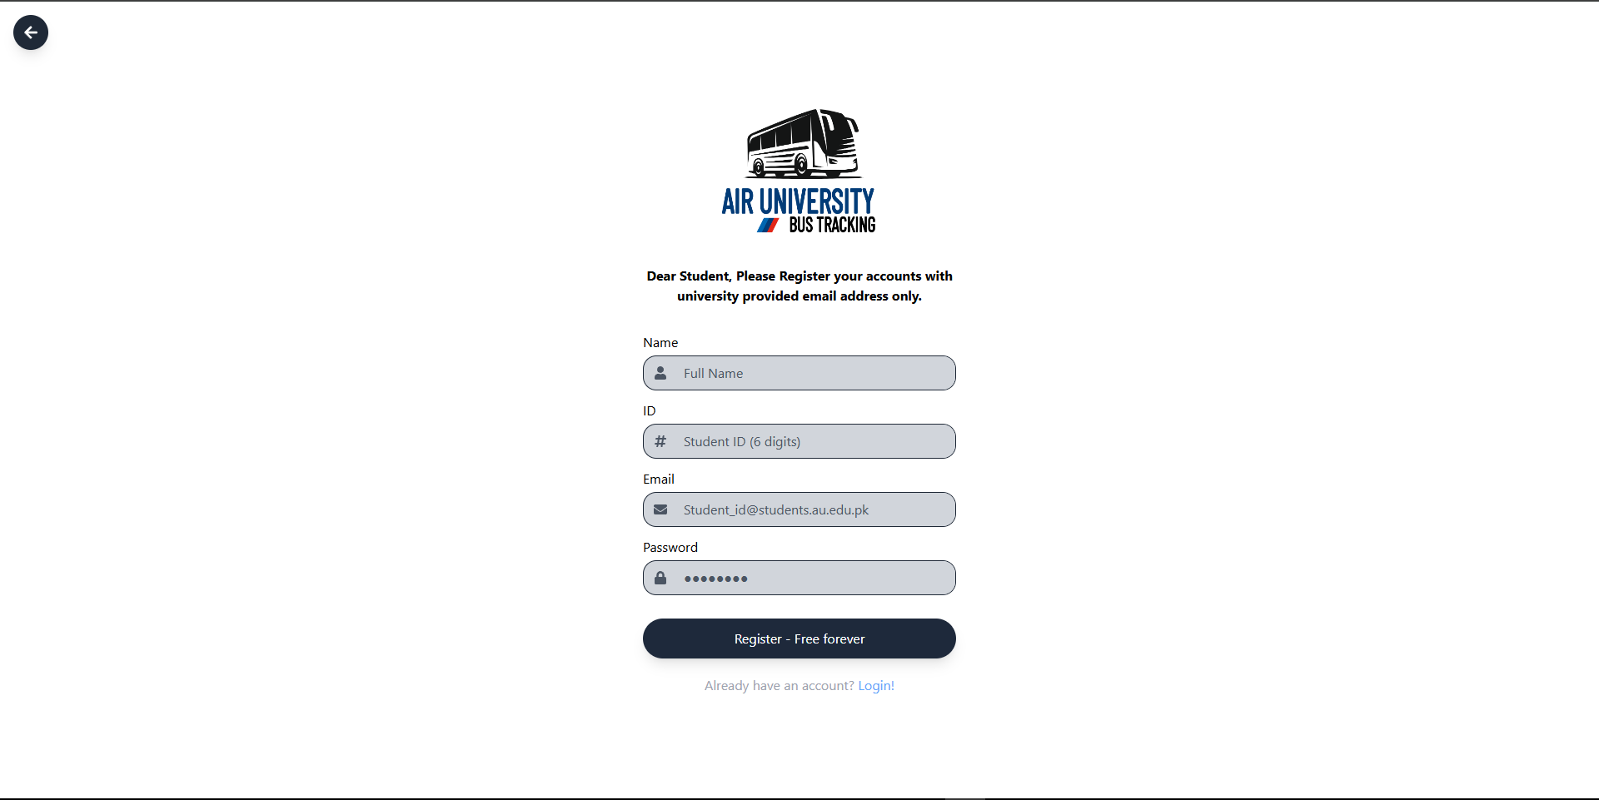

Login Page.
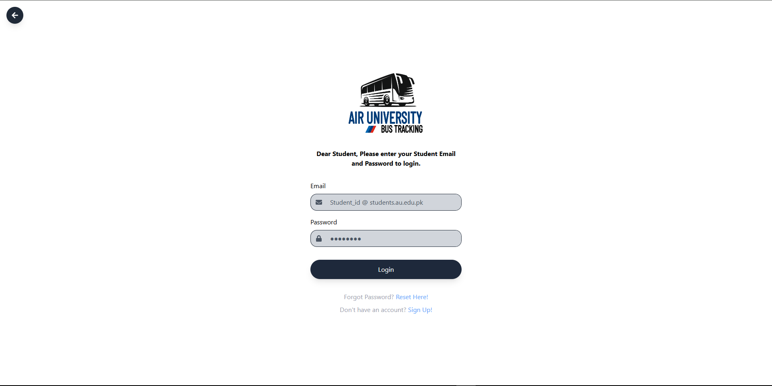

Home Page / User Dashboard where user can see their selected stops, and can track live location of the bus.
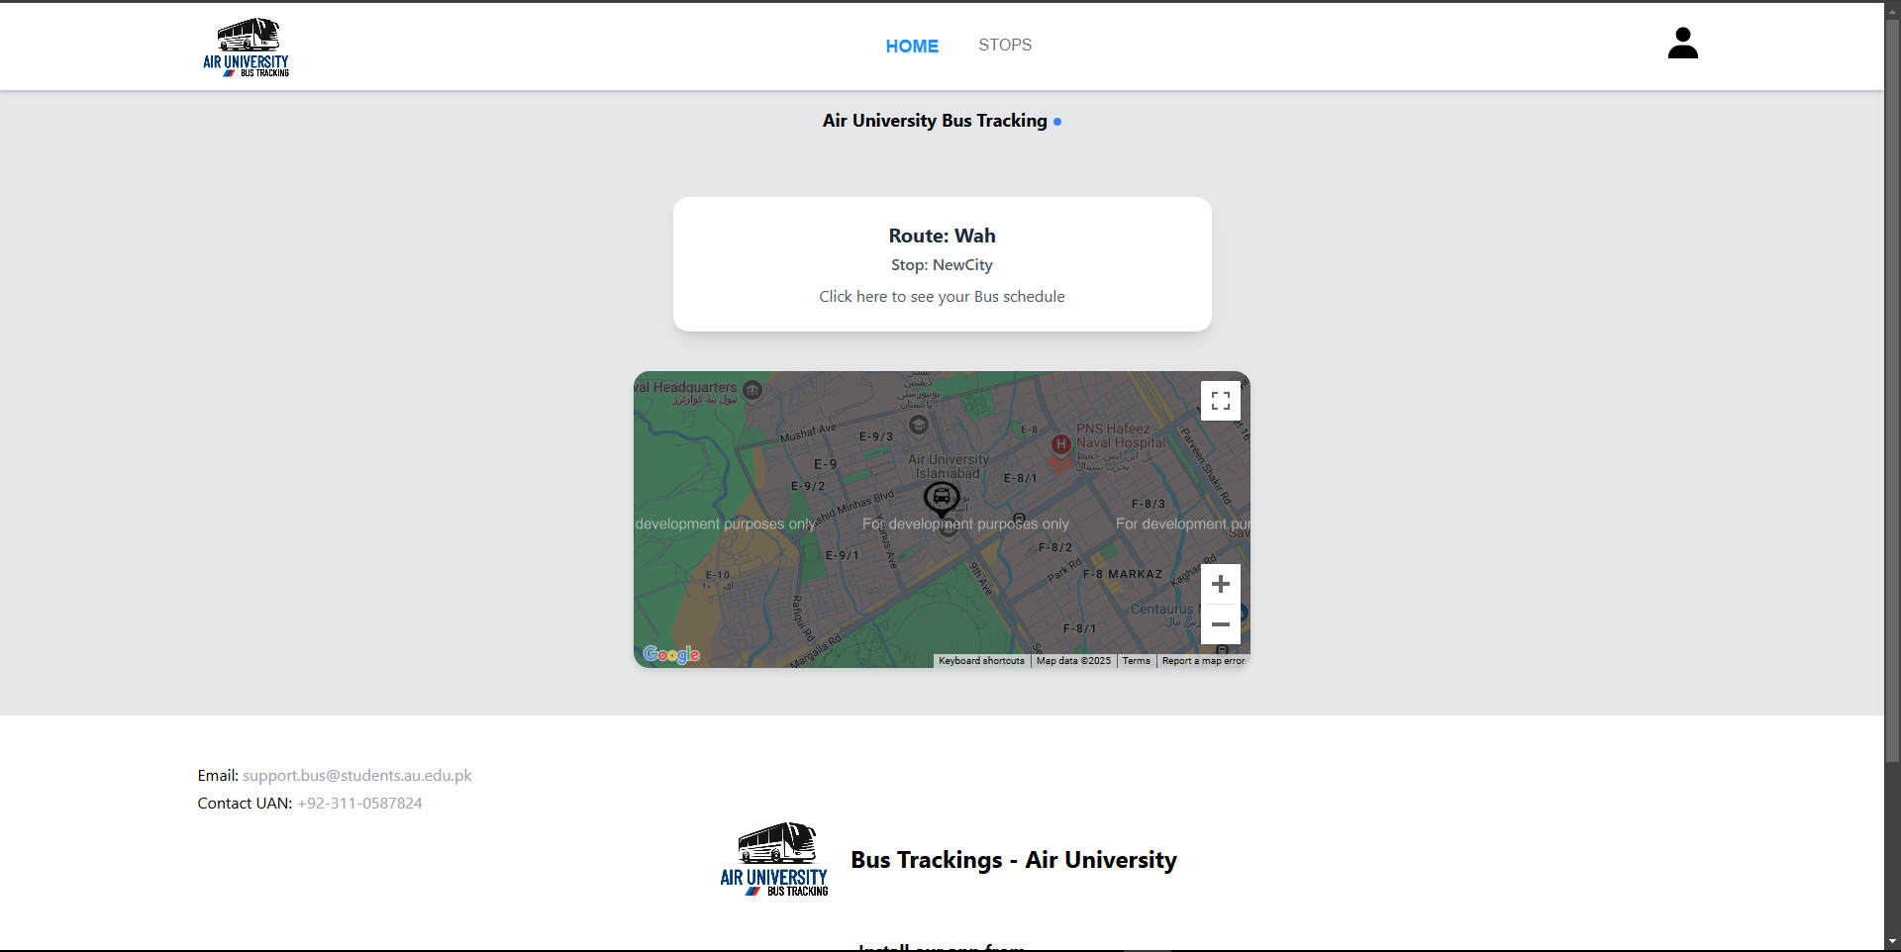

Allowing user to change their stop.
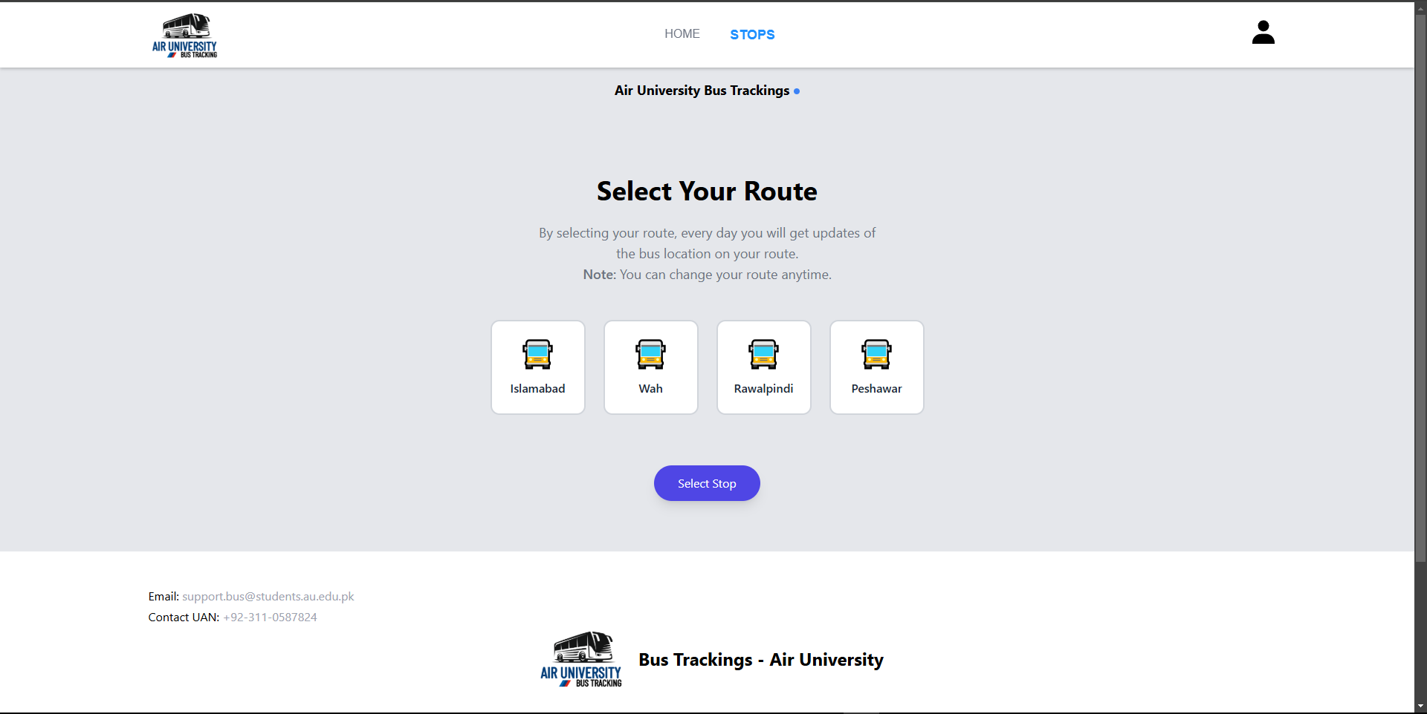

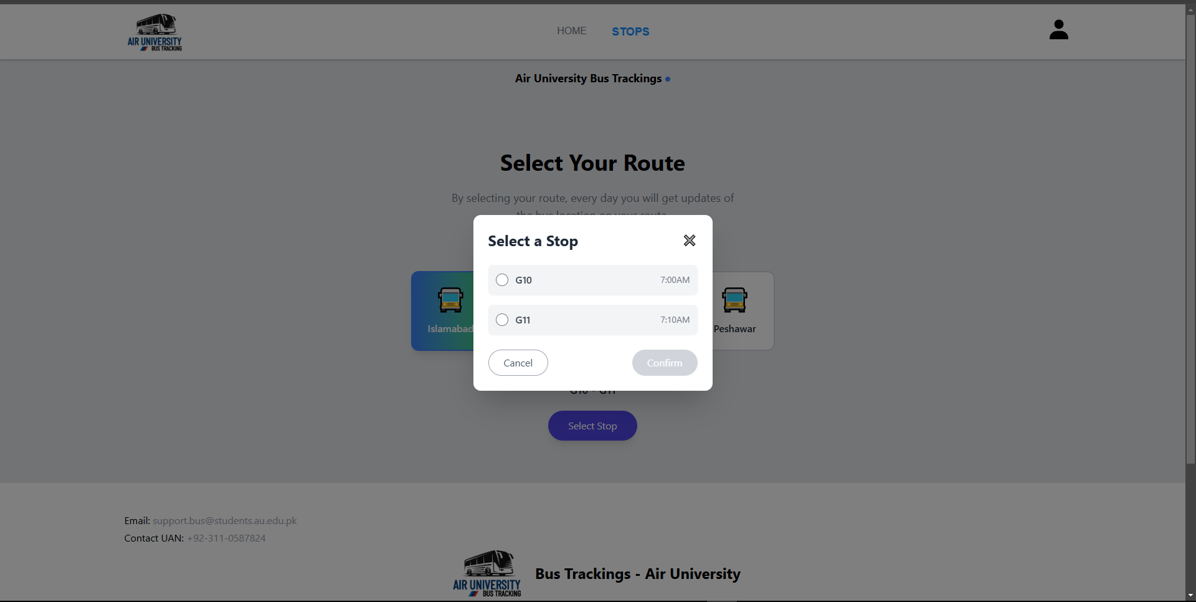

Allowing user to add or edit their personal details.
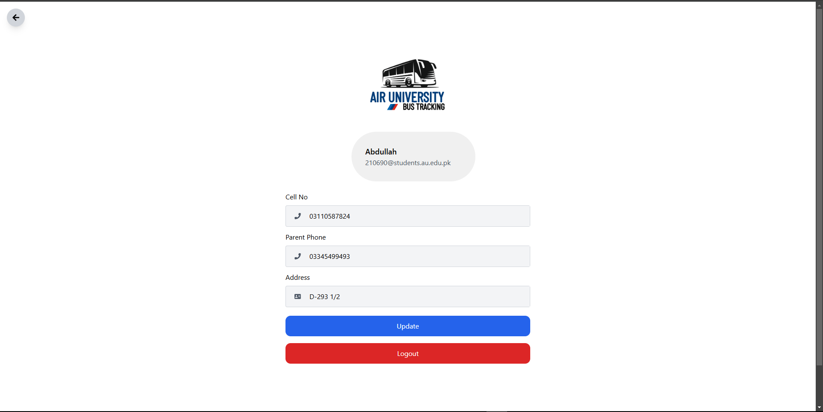

Allowing user to track Live location of their Bus.

Now, Lets move towards Admin Dashboard.

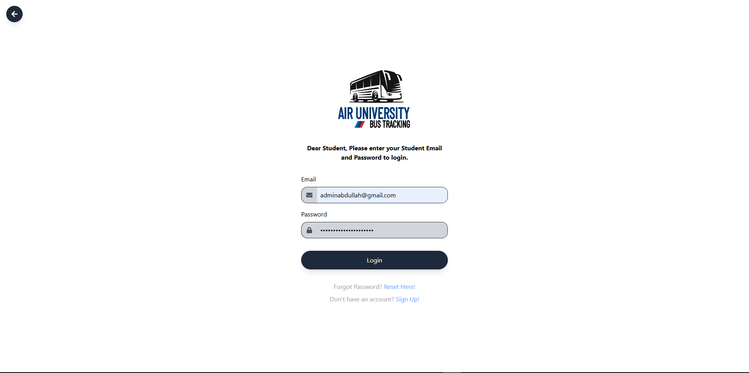

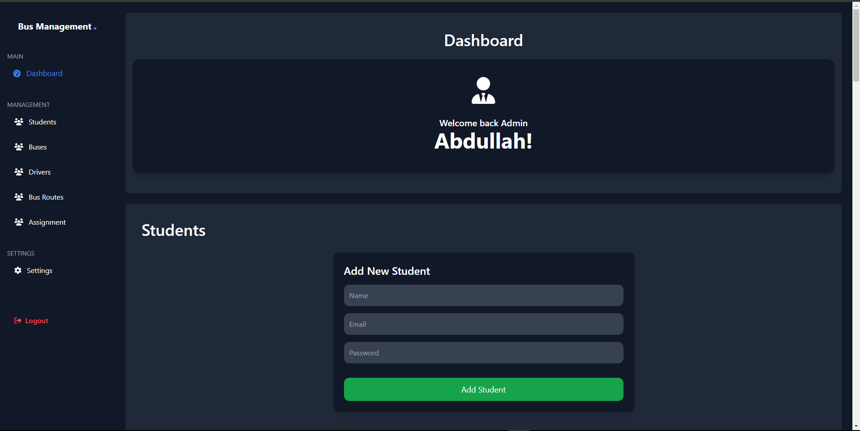

Admin can Add users and see existing user details, with the right to delete a user.
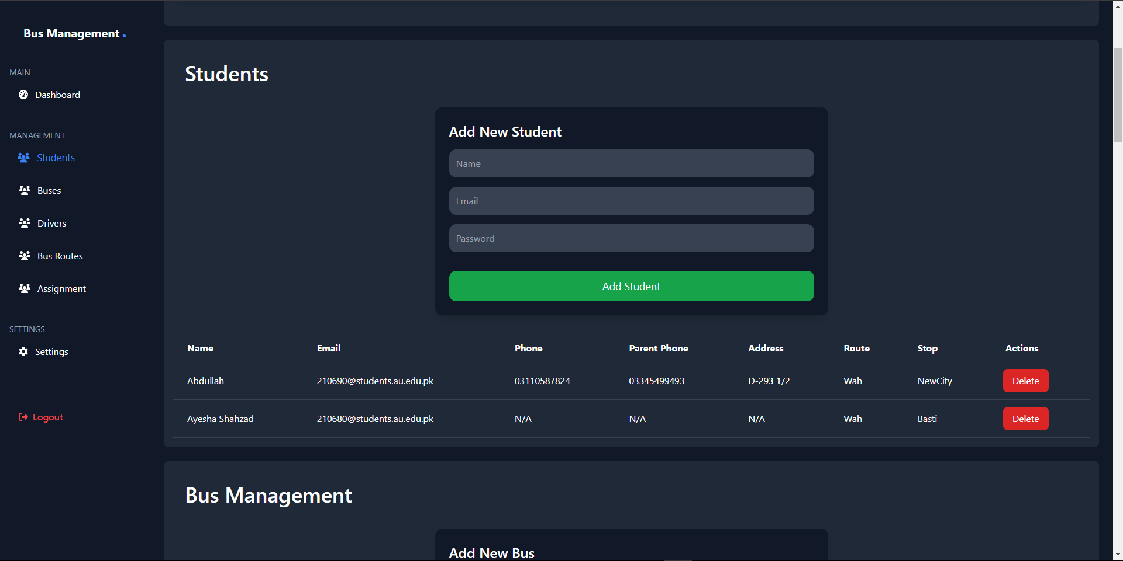

Admin can Add Buses and see existing bus details, with the right to delete or modify any bus details.
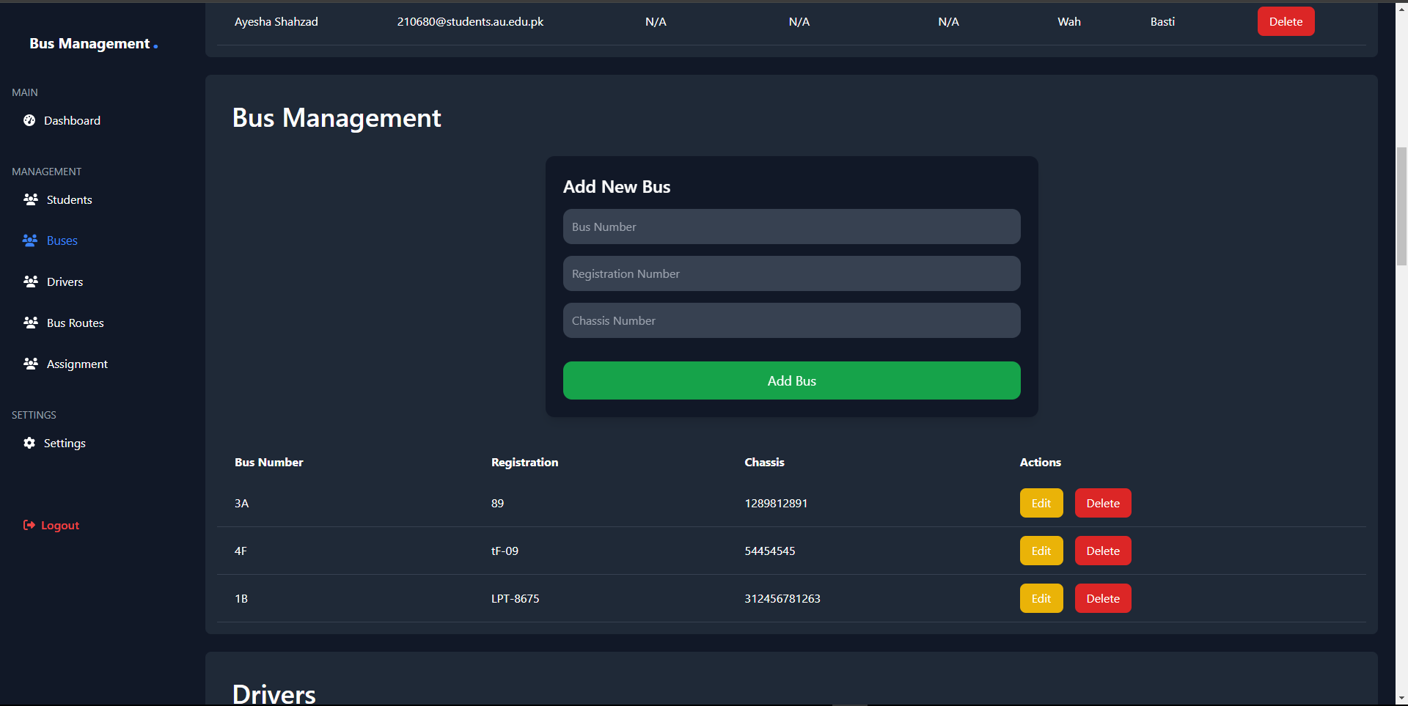

Admin can Add Drivers and see existing driver details, with the right to delete or modify any driver details.
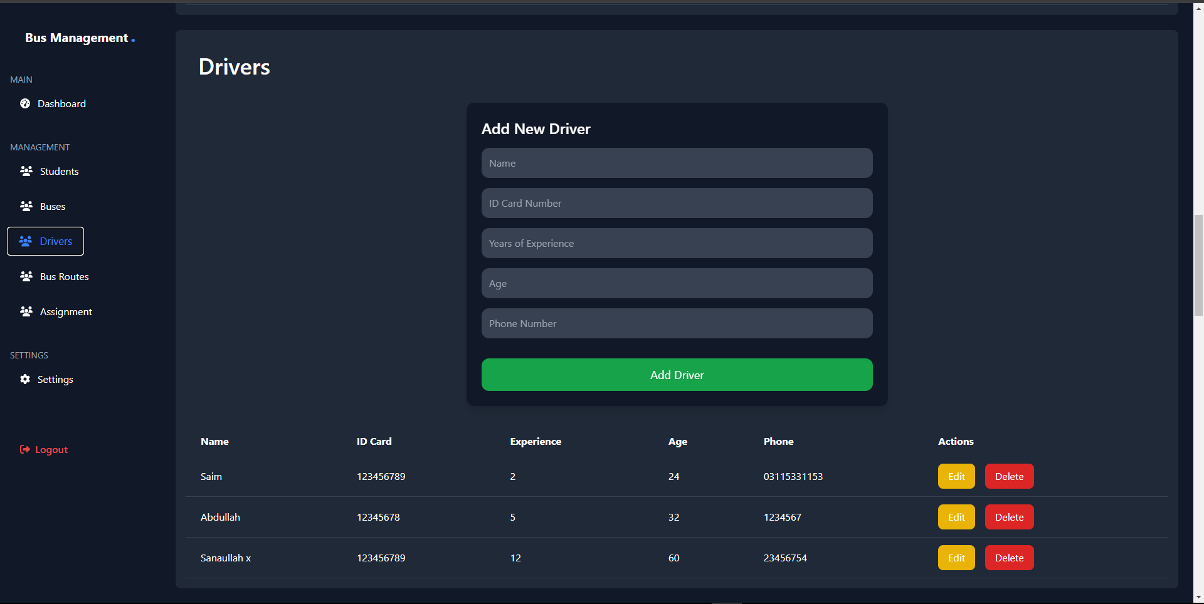

Admin can Add Routes and Stops against each route, see existing route details, with the right to delete or modify any the details.
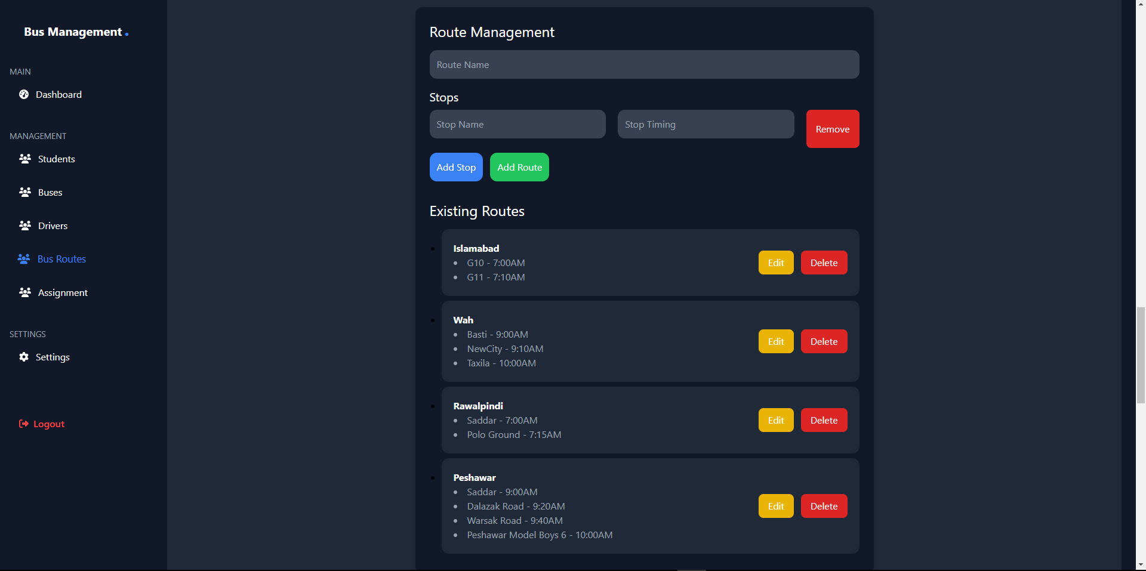

Admin can Assign Buses with Drivers and Routes, each driver and route can only be assigned to one bus at a time. Admin can see existing assignment details, with the right to assign any bus with any of the available drivers and routes.
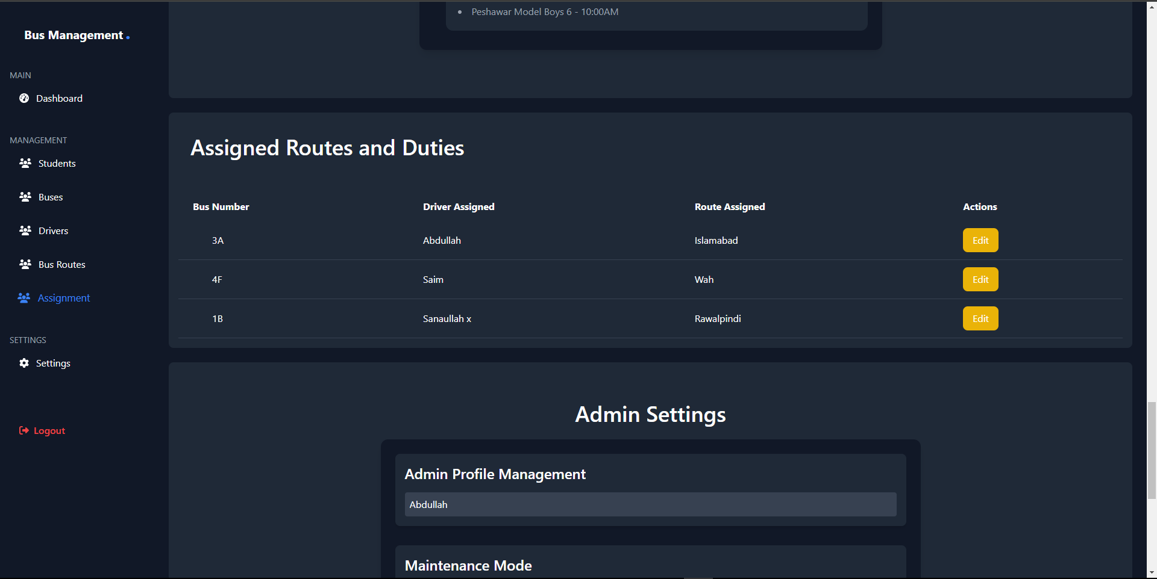

Admin can change Admin name which will be displayed on the top, and can also put the website into maintenance mode.
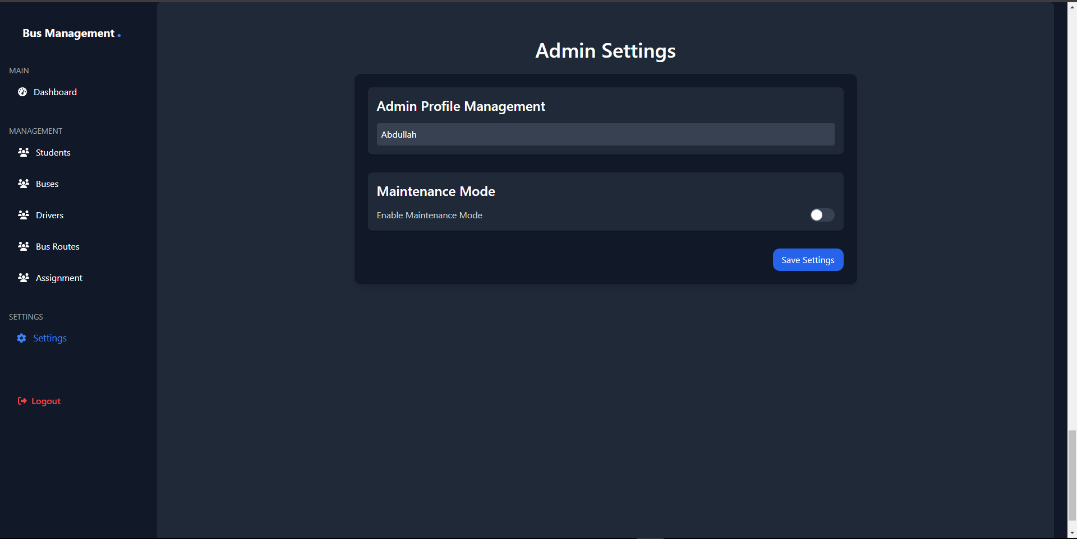

Maintenance mode demo... Let’s turn on the Maintenance mode…
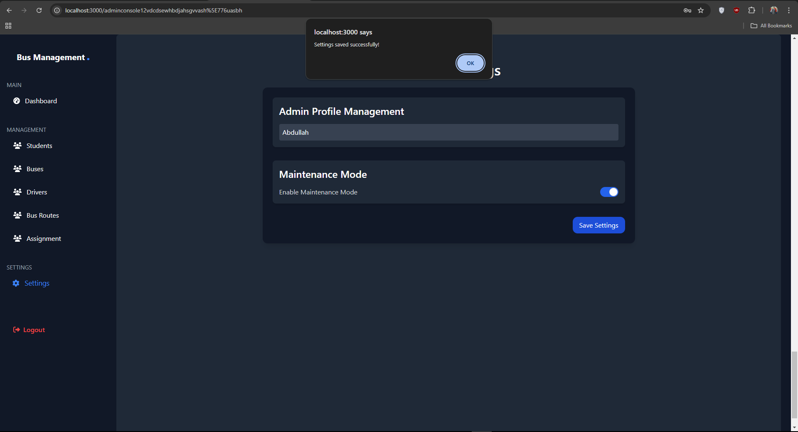

Now let’s access the website… It should not be accessible anymore until admin turns off the maintenance mode.
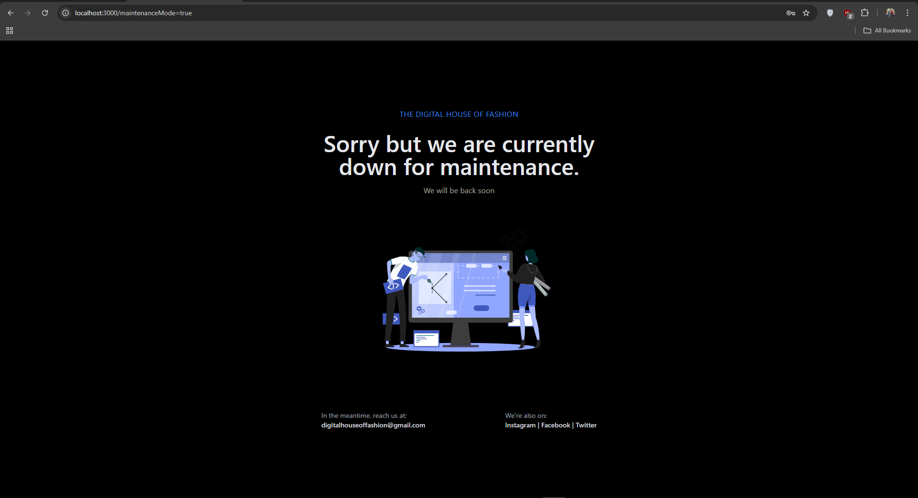

Application Interface

Now let’s access the mobile application… Student can login using the details existing inside Database. If not, user must have to register first using Web. And then student see the details.
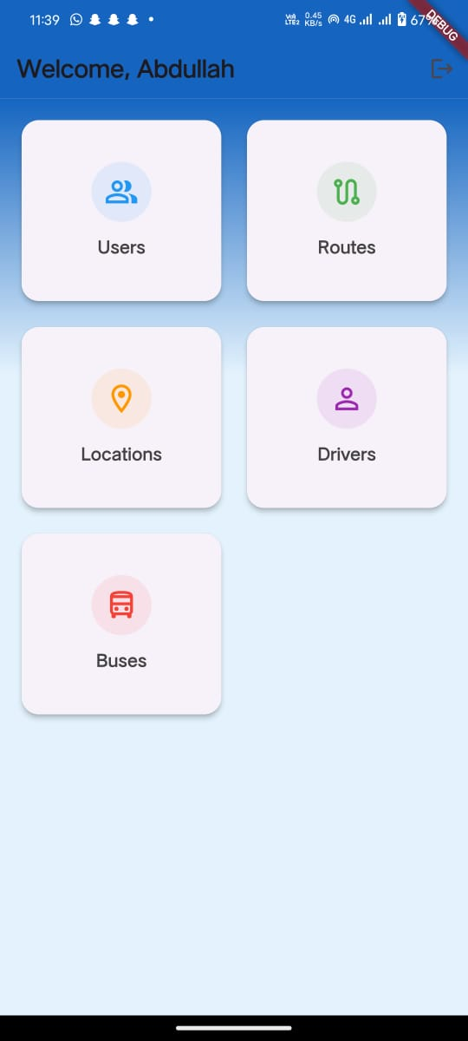
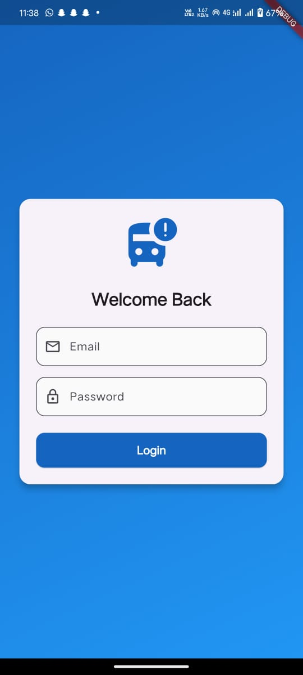

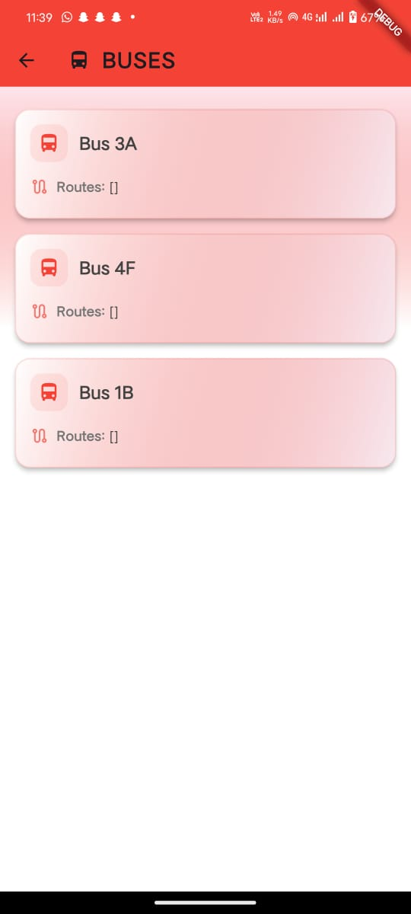
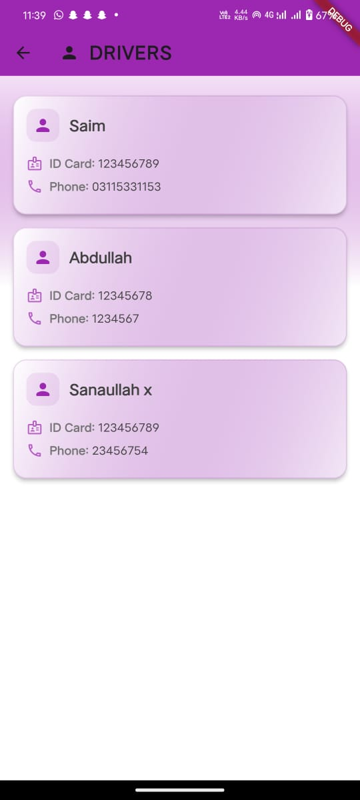
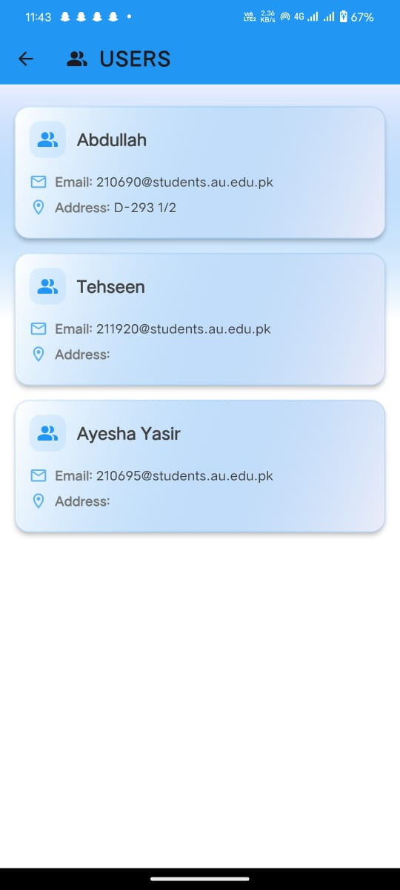
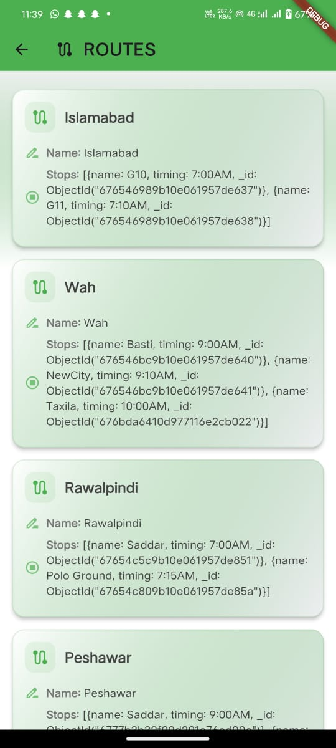
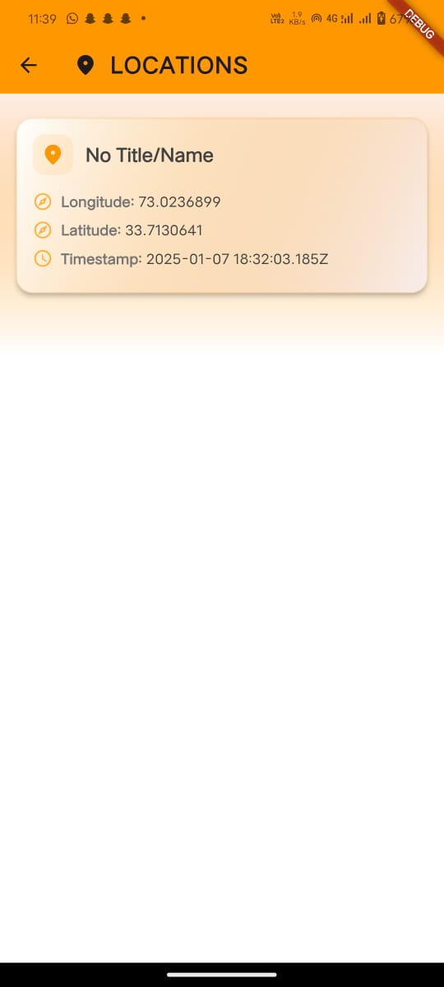

Arduino and Hardware
Arduino sending location coordinates via GPS Tracker.
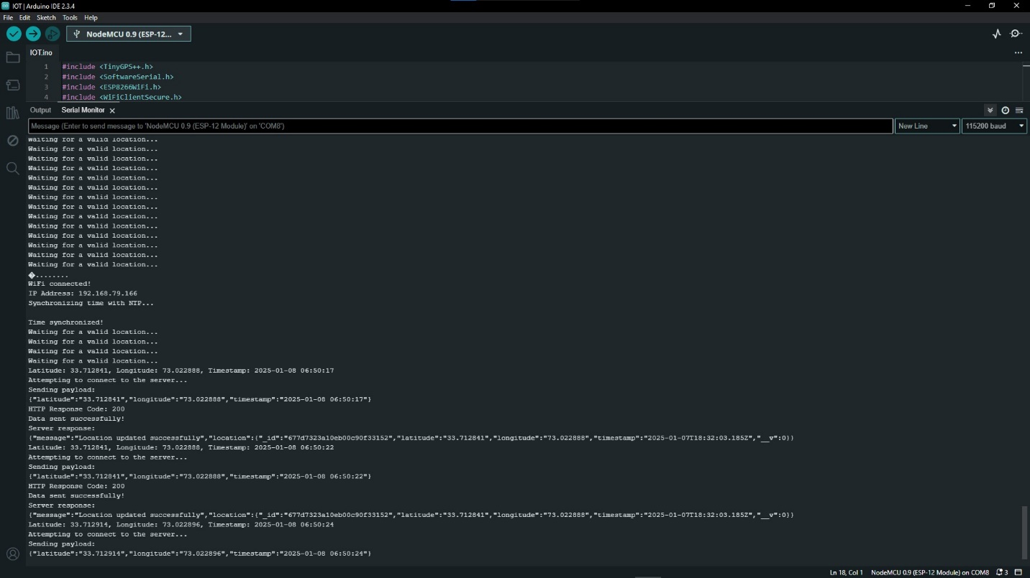

Data received at Mongo DB.
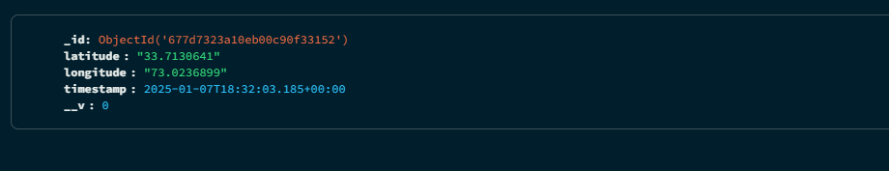

Location fetching from Mongo and Displaying on the Website.

Hardware Prototype.
